Caching static files with Amazon CloudFront

**SPL-36 - Version 3.2.21**

© 2023 Amazon Web Services, Inc. or its affiliates. All rights reserved. This work may not be reproduced or redistributed, in whole or in part, without prior written permission from Amazon Web Services, Inc. Commercial copying, lending, or selling is prohibited. All trademarks are the property of their owners.

Note: Do not include any personal, identifying, or confidential information into the lab environment. Information entered may be visible to others.

Corrections, feedback, or other questions? Contact us at [*AWS Training and Certification*](https://support.aws.amazon.com/#/contacts/aws-training).

Lab overview

Amazon CloudFront is a web service that accelerates the delivery of your content to your users through Amazon CloudFront’s global network of edge locations. In this lab you will learn how to start distributing your content with Amazon CloudFront by taking a simple static website in Amazon S3 and integrating it with Amazon CloudFront to deliver your website content from our 50+ edge locations.

The majority of this lab will focus on creating a Amazon CloudFront distribution with the AWS Management Console and adapting the existing webpages to use Amazon CloudFront. At the end of the lab, you will be able to accelerate your static website, and improve your user’s experience in a fast, reliable, and scalable way. Let us get started.

**Topics covered**

This lab will demonstrate how to:

* Create and configure an Amazon CloudFront web distribution
* Update and invalidate your content on Amazon CloudFront
* Test your content from both Amazon S3 and Amazon CloudFront

**Technical knowledge prerequisites**

To successfully complete this lab, you should be familiar with the AWS Management Console and basic html.

**Amazon CloudFront**

Amazon CloudFront is a content delivery web service. It integrates with other Amazon Web Services products to give developers and businesses an easy way to distribute content to end users with low latency, high data transfer speeds, and no minimum usage commitments.

Amazon CloudFront can be used to deliver your entire website, including dynamic, static, streaming, and interactive content using a global network of edge locations. Requests for your content are automatically routed to the nearest edge location, so content is delivered with the best possible performance. Amazon CloudFront is optimized to work with other Amazon Web Services, like Amazon Simple Storage Service (Amazon S3), Amazon Elastic Compute Cloud (Amazon EC2), Amazon Elastic Load Balancing, and Amazon Route 53. Amazon CloudFront also works seamlessly with any non-AWS origin server, which stores the original, definitive versions of your files. Like other Amazon Web Services products, there are no long-term contracts or minimum monthly usage commitments for using Amazon CloudFront – you pay only for as much or as little content as you actually deliver through the content delivery service.

**Amazon S3**

Amazon Simple Storage Service (Amazon S3), provides developers and IT teams with secure, durable, highly-scalable object storage. Amazon S3 is easy to use, with a simple web services interface to store and retrieve any amount of data from anywhere on the web. With Amazon S3, you pay only for the storage you actually use. There is no minimum fee and no setup cost.

Amazon S3 can be used alone or together with other AWS services such as Amazon Elastic Compute Cloud (Amazon EC2), Amazon Elastic Block Store (Amazon EBS), and Amazon Glacier, as well as third party storage repositories and gateways. Amazon S3 provides cost-effective object storage for a wide variety of use cases including cloud applications, content distribution, backup and archiving, disaster recovery, and big data analytics.

**Start lab**

1. To launch the lab, at the top of the page, choose **Start lab**.

 You must wait for the provisioned AWS services to be ready before you can continue.

1. To open the lab, choose **Open Console**.

You are automatically signed in to the AWS Management Console in a new web browser tab.

**Do not change the Region unless instructed.**

COMMON SIGN-IN ERRORS

**Error: You must first sign out**

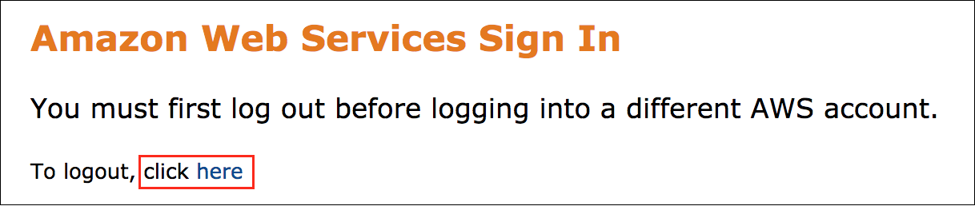

If you see the message, **You must first log out before logging into a different AWS account:**

* Choose the **click here** link.
* Close your **Amazon Web Services Sign In** web browser tab and return to your initial lab page.
* Choose **Open Console** again.

**Error: Choosing Start Lab has no effect**

In some cases, certain pop-up or script blocker web browser extensions might prevent the **Start Lab** button from working as intended. If you experience an issue starting the lab:

* Add the lab domain name to your pop-up or script blocker’s allow list or turn it off.
* Refresh the page and try again.

**Task 1: Review the static website hosted in your Amazon S3 bucket**

This lab starts with a static website hosted in Amazon S3 for your use. On the left side of these instructions there are two resources for the website, namely:

* **S3Bucket**: this is the S3 bucket containing the files that makeup the static website.
* **StaticWebsiteURL**: this is the path to your initial static website.

1. In the AWS search bar of the AWS Management Console, search for

S3

 and then choose the service from the list.

1. Choose the bucket that matches the value of **S3Bucket** to the left of these instructions.

You should see 5 files in the Amazon S3 bucket.

1. Choose the file

cf_lab1.html

1. Choose **Open**

This will open the file in a web browser tab. You should see a picture of the Grand Canyon.

1. Return to the **S3 Management Console** tab.
2. Choose the **Permissions** tab.

An Amazon S3 bucket is a container that can hold objects or folders. Amazon CloudFront can distribute almost any type of object that an Amazon S3 bucket contains, for example, text, images, and videos. You can create multiple buckets, and there is no limit to the amount of data that you can store on Amazon S3.

By default, your Amazon S3 bucket and all of the objects in it are private. Only the AWS account that created the bucket has permission to read or write the objects in it. If you want to allow anyone to access the objects in your Amazon S3 bucket using Amazon CloudFront URLs, you can grant access to the S3 objects so that they’re accessible only via Amazon CloudFront using Origin Access Identity.

However, **in this lab, the files have been made public for you**.

**Task 2: Create an Amazon CloudFront web distribution**

1. In the AWS search bar of the AWS Management Console, search for

CloudFront

 and then choose the service from the list.

1. Choose **Create a CloudFront distribution**

This will bring you to the **Create distribution** page.

1. For **Origin domain**, select the value of **S3Bucket**.

*The value of S3Bucket is located to the left of these instructions.*

1. For **Web Application Firewall (WAF)**, choose **Do not enable security protections**.
2. For the other settings, leave everything at defaults.

The settings will:

* Forward all requests that use the Amazon CloudFront URL for your distribution ( for example, *http://d111111abcdef8.cloudfront.net/grand_canyon.JPG* ) to the Amazon S3 bucket that you specified previously.
* Allow end users to use either HTTP or HTTPS to access your objects.
* Exclude cookies and query string parameters, if any, when forwarding requests for objects to your origin. (For more information on Cookie and query strings, see the Dynamic Content Acceleration with Amazon CloudFront Lab.)
* Allow everyone to view your content.

In this lab the default distribution settings will be used. However, feel free to examine what each setting does.

After Amazon CloudFront has created your distribution, the value of the **Last modified** will change from **Deploying** to **Current Date**.

1. Choose **Create distribution**.

**Task 3: Test your static website from an Amazon CloudFront distribution**

 Congratulations! You have created an Amazon CloudFront Distribution. Your content is ready to be accessed throughout the world on Amazon CloudFront’s edge network. To review, Amazon CloudFront knows where your Amazon S3 origin server is, and you know the domain name associated with the distribution. You can create a link to your Amazon S3 bucket content with the Amazon CloudFront domain name, and have Amazon CloudFront serve it.

1. Copy the **Distribution domain name** that Amazon CloudFront assigned your distribution to your text editor. Do not copy the

https://

 part of the domain name.

The **Domain Name** will look similar to *d3qgea68yl9p1c.cloudfront.net*

1. Create a new text document.
2. Copy the following HTML and paste into your new text file.

<html>

<head>

My CloudFront Test

</head>

<body>

<p>My text content goes here.</p>

<p><img src="https://NAME/grand_canyon.jpg " alt="my test image" /></p>

</body>

</html>

1. Replace **NAME** with the **Domain Name** that you copied to your text editor.
2. Save the text file to your computer with the file name:

cf_lab1_test.html

.

1. Make sure the extension is **.html**.
2. Once the distribution is **Deployed**, open your test web page in a browser (**cf_lab1_test.html**).

You should see a web page that contains some text and a photo of the Grand Canyon. If you cannot see the content, confirm that you have performed all of the steps correctly and that your distribution is Deployed.

The browser returns your page with the embedded image file, served from the edge location that CloudFront determined was the fastest to serve the object.

**Task 4: Test your full site hosting**

Because your complete cf_lab1 test web site was created in your Amazon S3 bucket as part of the lab startup, you can fully host the site using Amazon CloudFront. In this task you will test your domain.

1. In a new browser tab:

* Paste your Amazon CloudFront Domain Name
* At the end of the Domain Name, append

/cf_lab1.html

* Press **Enter**.

Here is an example: *https://d3qgea68yl9p1c.cloudfront.net/cf_lab1.html*

1. Right-choose the Grand Canyon image and copy the image location to your clipboard.
2. Paste the image location into a new tab and press **Enter**.

Notice the URL and that the image is also, automatically, hosted by Amazon CloudFront.

To get your own domain name (such as *www.example.com*) to point to this distribution, you will need to set up a CNAME. This is outside the scope of this lab.

**Task 5: Updating your site cached content**

Now that you have the site up and running through Amazon CloudFront, consider how to properly update your site. The content is now potentially cached across all of Amazon CloudFront’s edge locations. The copies of your objects remain in these locations for up to 24 hours by default. Normally, this is great. Your objects are closer to the end user and will be served to them quickly. But, what if you want to change an object? The following section shows you how to update a site and distribute changes to the edge locations in a timely manner.

FILE VERSIONING

The simplest method of updating an object in Amazon CloudFront is to use file versioning. To do this, you can upload the new Grand Canyon picture to Amazon S3 using a new name (such as **grand_canyon_v2.jpg**). Once you upload the image, you must change the files that use the content.

1. In the **cf_lab1_test.html** file:

* Change the name of the picture to

grand_canyon_v2.jpg

* Save the file

Your updated file should look similar to this:

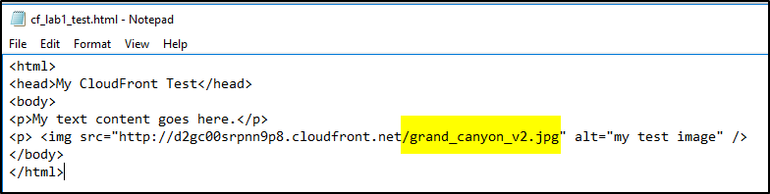

1. Open the updated **cf_lab1_test.html** file using your web browser.

REPLACING OR REMOVING AN OBJECT: LESSONS IN REDUNDANCY

Sometimes, file versioning is not the appropriate solution. In these cases, removing or replacing the file in Amazon S3 will not immediately fix the problem. Let us see what happens.

1. Load the **cf_lab1.html** website from **both** Amazon S3 and Amazon CloudFront. Both should show the *Grand Canyon* image.

* The S3 url is available to the left of these instructions. Labled *StaticWebsiteURL*
* The Amazon CloudFront URL will be similar to: *http://d3qgea68yl9p1c.cloudfront.net/cf_lab1.html*

1. In the AWS search bar of the AWS Management Console, search for

S3

 and then choose the service from the list.

1. Choose the Amazon S3 bucket that you used earlier.
2. Select  **cf_lab1.html**.
3. Choose **Delete**
4. Type **permanently delete**, and choose **Delete objects**
5. Choose **Close**
6. Refresh both the Amazon S3 and Amazon CloudFront hosted websites in your browser.

You should continue to see the previous site in the Amazon CloudFront distribution, and you should receive an XML error in the Amazon S3 bucket.

**S3 Location** 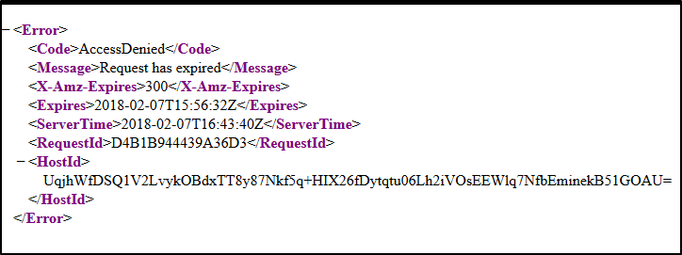

**CloudFront Cached Copy** 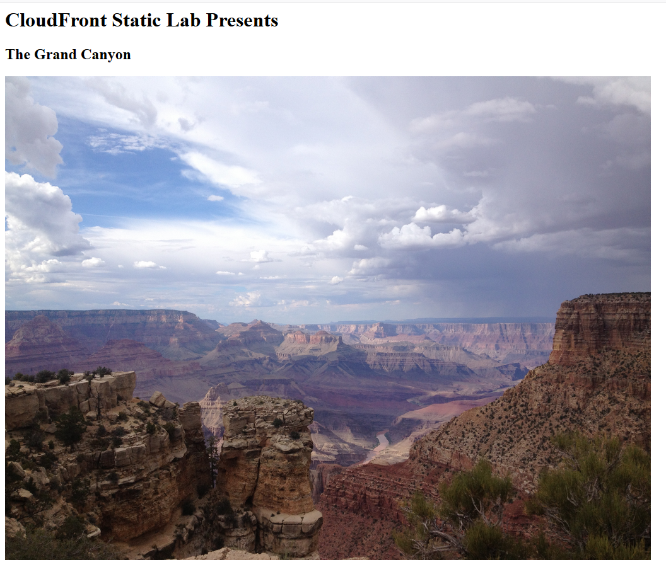

Redundant copies of your site increase your availability. For example, if your origin is unavailable, Amazon CloudFront will still deliver cached content to your users.

Next, you will replace **cf_lab1.html** with a new file containing information on the Highlands of Scotland instead of the Grand Canyon.

1. In the **S3 Management Console** select  **cf_lab1-highlands.html**.
2. From the **Actions** tab, choose **Rename object**.
3. Enter

cf_lab1.html

1. Choose **Save changes**.
2. Refresh both the Amazon S3 and Amazon CloudFront versions of **cf_lab1.html** in your browser.

You should continue to see the Grand Canyon content in the Amazon CloudFront version, and you should see the Scottish Highlands content in your Amazon S3 version.

This behavior results from the redundancy and caching behavior of Amazon CloudFront. **cf_lab1.html** was originally cached in Amazon CloudFront with the Grand Canyon content. It continues to serve this version of the file until the cache time expires (24 hrs by default).

**Task 6: Invalidate your cache**

To force Amazon CloudFront to remove **cf_lab1.html** you must invalidate the existing copy in the cache.

1. In the AWS search bar of the AWS Management Console, search for

CloudFront

 and then choose the service from the list.

1. Choose the distribution you created. *(This opens additional settings)*
2. Choose the **Invalidations** tab.
3. Choose **Create invalidation**
4. In the **Object paths** -> **Add object paths** field enter:

/cf_lab1.html

1. Choose **Create invalidation**

Wait for the Invalidation Status to change from **In Progress** to **Completed**. This may take several minutes. You may read the remainder of the lab while the invalidation progresses through Amazon CloudFront’s 50+ locations.

1. Once the Invalidation is complete, refresh your Amazon CloudFront version of **cf_lab1.html**.

You should now see the Scottish Highlands version of the web page, and it should match the Amazon S3 version of the file. The cached version of **cf_lab1.html** was removed. Refreshing the page caused Amazon CloudFront to pull the updated file from the origin (Amazon S3) and copied the new version to the cache.

If you have a file that is updated frequently, you can still use Amazon CloudFront to cache it, but you can customize your cache expiration time. You can also choose not to cache a file, and Amazon CloudFront will accelerate content distribution using persistent connections and optimized routing from the origin.

**Conclusion**

 Congratulations! You have now successfully:

* Created and configured an Amazon CloudFront web distribution
* Updated and invalidated your content on Amazon CloudFront
* Tested your content from both Amazon S3 and Amazon CloudFront

**End lab**

Follow these steps to close the console and end your lab.

1. Return to the **AWS Management Console**.
2. At the upper-right corner of the page, choose **AWSLabsUser**, and then choose **Sign out**.
3. Choose **End lab** and then confirm that you want to end your lab.

**Additional Resources**

* [AWS Training and Certification](http://aws.amazon.com/training)
* [What Is Amazon CloudFront?](https://docs.aws.amazon.com/AmazonCloudFront/latest/DeveloperGuide/Introduction.html)
* [Getting Started with CloudFront](https://docs.aws.amazon.com/AmazonCloudFront/latest/DeveloperGuide/GettingStarted.html)
* [Amazon CloudFront](http://aws.amazon.com/cloudfront)
* [Choosing the Price Class for a CloudFront Distribution](https://docs.aws.amazon.com/AmazonCloudFront/latest/DeveloperGuide/PriceClass.html)
* [Amazon CloudFront Pricing](https://aws.amazon.com/cloudfront/pricing/)
* [Adding and Moving Alternate Domain Names (CNAMEs)](https://docs.aws.amazon.com/AmazonCloudFront/latest/DeveloperGuide/CNAMEs.html)
* [Using HTTPS with CloudFront](https://docs.aws.amazon.com/AmazonCloudFront/latest/DeveloperGuide/using-https.html#cnames-and-https-requirements)
* [Using an Origin Access Identity to Restrict Access to Your Amazon S3Content](https://docs.aws.amazon.com/AmazonCloudFront/latest/DeveloperGuide/private-content-restricting-access-to-s3.html)
* [Adding and Moving Alternate Domain Names (CNAMEs)](https://docs.aws.amazon.com/AmazonCloudFront/latest/DeveloperGuide/CNAMEs.html)
* [Specifying How Long Objects Stay in a CloudFront Edge Cache (Expiration)](https://docs.aws.amazon.com/AmazonCloudFront/latest/DeveloperGuide/Expiration.html)
* [CloudFront Troubleshooting](http://docs.aws.amazon.com/AmazonCloudFront/latest/DeveloperGuide/Troubleshooting.html)

For more information about AWS Training and Certification, see [*https://aws.amazon.com/training/*](https://aws.amazon.com/training/).

*Your feedback is welcome and appreciated.*  
If you would like to share any feedback, suggestions, or corrections, please provide the details in our [*AWS Training and Certification Contact Form*](https://support.aws.amazon.com/#/contacts/aws-training).